ROLE PROFILE

JOB TITLE: | Administration Coordinator | SALARY: | £25,000 - £28,000
REPORTING TO: | Business Administration Manager | HOLIDAYS: | 33 days including bank holidays
LOCATION: | Future Youth Zone, 201-225 Porters Avenue, Dagenham, RM 5YX | HOURS: | Full time - 40 hours per week, including flexibility to work evenings and weekends as required
THE PERSON: | The successful candidate will be a diligent and organised individual who can multitask and is confident working in a fast paced environment. You will flourish when working as part of a team but can also focus independently to ensure that tasks are completed in a timely and accurate manner. You are passionate and driven to ensure that young people get the very best service.
KEY RELATIONSHIPS: | Business Administration Manager, Membership Coordinators, Finance Manager (external), Head of Youth Work, Head of Fundraising, Head of Education, CEO, suppliers, young people and parents/carers.

JOB PURPOSE:

To provide administration and finance support to enable the smooth running of Youth Zone activities, including but not limited to: running the Youth Zones’ day-to-day financial procedures, ensuring that all visitors get a warm and hospital welcome through management of the reception team and utilising our systems to support the wider team monitor and evaluate our work.

CONTEXT OF THE POST:

Barking and Dagenham Youth Zone, named ‘Future’ by local young people, is the first Youth Zone in London opened by the national charity, OnSide in May 2019. This is an exciting and unique opportunity to join a small but growing, impactful fundraising team and play a critical part in shaping opportunities for East London’s young people and supporting a grass roots, committed, universal youth service.

Future, like all OnSide Youth Zones, exists to give young people, particularly those who are disadvantaged, somewhere to go, something to do and someone to talk to. The Youth Zone is open 7 days a week, at weekends and during school holidays. The Youth Zone’s purpose is to help young people grow to be happy, healthy and successful adults.

Future’s state-of-the-art £6.15 million building on Parsloes Park, provides young people with access to a range of activities, offering them the opportunity to try new things, meet new friends and gain support from friendly, warm and positive staff and volunteers. The facilities include a 3G pitch, a gym, sports hall, recreation area and dance, arts, music and media suites, with state-of-the-art facilities equipped for a wide range of sporting, artistic, cultural and general recreational activities and targeted services. The Youth Zone supports young people like Monique, Owen and Bola to grow and develop.

DUTIES AND RESPONSIBILITIES – DETAILED

- To provide comprehensive administration support in all areas of the Youth Zone’s operation.
- To run the day-to-day financial procedures of the Youth Zone, including using Sage to post purchase invoices, raise sales invoices, reconciliations, making supplier payments, collating and making staff expense payments, preparing incoming funds for cash collection and respond to finance queries.
- Set high standards with regards to financial processes and ensure that these are adhered to by all colleagues.
- Maintain the Youth Zone membership database system.
- To deputise in the absence of the Business Administration Manager.
- To assist the youth work team in recording and evaluating work and providing reports, statistics and other relevant information as required, both internally and externally.
- Line manage membership coordinators and administration apprentice.
- Ensure there is a rota in place including any appropriate cover for reception.
- Be a positive point of contact for all enquiries from external stakeholders including parents/carers.
- To assist the Chief Executive and Head of Youth Work in monitoring progress against targets and measuring the impact of the Youth Zone.
- Take responsibility for maintaining the reception area at the Youth Zone and providing a welcoming environment, acting as the first point of contact for Youth Zone members, staff, volunteers, suppliers, visitors and the general public.
- To assist with any general administration and communication functions as required
- To carry out any other reasonable duties as requested by manager

DUTIES AND RESPONSIBILITIES - GENERAL

- Be a role model for young people and present a positive “can do” attitude.
- Take personal responsibility for own actions.
- Commit to a culture of continuous improvement.
- Work within the performance framework of Future Youth Zone and OnSide.
- Represent Future Youth Zone positively and effectively in all dealings with internal colleagues, and external partners.
- To be alert to issues of safeguarding and child protection, ensuring the welfare and safety of Youth Zone members is promoted and safeguarded, and to report any child protection concerns to the designated Child Protection Officers using the safeguarding policies, procedures and practice (training to be provided).
- To assist with any promotional activities and visits that take place at the Youth Zone.
- To adhere to Future Youth Zone policies at all times, with particular reference to Health and Safety, Safeguarding and Equal Opportunities

PERSON SPECIFICATION

Selection Criteria*  A = Application Form I = Interview | Essential / Desirable | Method of Assessment
Experience
Experience of administration functions including financial administration tasks | Essential | A & I
Experience of working with a range of IT systems including SAGE. | Essential | A & I
Experience of working within a team and prioritising work | Essential | A & I
Experience of organising tasks and activities to ensure that priorities are met | Essential | A & I
Managing or supervising a reception desk or entrance point | Desirable | A & I
Working in a customer facing environment | Essential | A & I
Dealing with the general public | Essential | A & I
Handling cash | Essential | A & I
Experience using a membership system or database | Essential | A & I
Experience working with young people | Desirable | A & I
Skills
Excellent written and verbal communication skills | Essential | A & I
Excellent organisational, communication and interpersonal skills | Essential | A & I
Ability to cope with multiple demands and deadlines | Essential | A & I
Willingness to support the Youth Work team in ensuring a safe, fun and welcoming environment for all young people | Essential | A & I
Ability to diffuse pressurised situations while remaining calm and in control | Essential | A & I
Ability to work on own initiative and as part of a team | Essential | A & I
Highly developed IT skills including MS Office, and databases | Essential | A & I
Excellent time keeper | Essential | A & I
Educational / Vocational Qualifications
GCSE in Maths and English or equivalent | Essential | A
A basic finance qualification. | Desirable | A
A basic IT, computer literacy qualification | Desirable | A
Knowledge
Understanding the challenges faced by young people and issues faced in their lives | Desirable | A & I
An understanding of safeguarding. | Desirable | A & I
Special Requirements
A willingness to work unsociable hours | Essential | I
A willingness to cover events, holidays and staff absence | Essential | I
DBS clearance and committed to Safeguarding children | Essential | A & I

*Selection criteria for guidance only, alternative methods may be used to assist the selection process

Future Youth Zone is committed to the safeguarding of young people. In accordance with our Child Protection and Safeguarding procedures, this position requires a enhanced DBS check.

The strength of OnSide Youth Zones comes from the diversity of the people within our vibrant network. We are proud that our Youth Zone teams reflect the communities they serve, and we value people working together from a range of different backgrounds locally and nationally, and with different experiences, all with a shared passion for boosting the aspirations of young people across the country. Diversity brings innovation, fresh ideas and creativity, and we actively strive to create a culture that is truly inclusive and fair for all and where everyone in the team can be themselves and thrive.
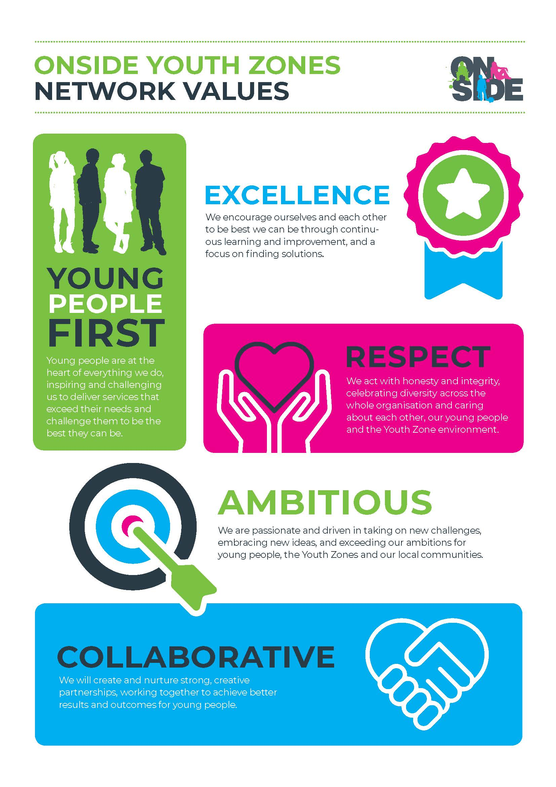
For information regarding how Future Youth Zone and OnSide Youth Zones process your data, please visit www.onsideyouthzones.org/applicant-privacy/

