What Does Safeguarding Mean for Youth Zone Trustees?

Safeguarding children and promoting their welfare includes:

- Protecting them from maltreatment or things that are bad for their health or development.
- Making sure that they grow up in circumstances that allow and enable safe and effective care.

Safeguarding adults at risk of harm includes:

- Protecting their right to live in safety, free from abuse and neglect.
- Making sure people’s wellbeing is promoted, taking their views, wishes, feelings and beliefs into account.

Safeguarding is everyone’s responsibility

Collective responsibility is very relevant when we talk about safeguarding responsibilities within a Youth Zone. Everyone has a part to play to protect young people: staff, trustees, volunteers and visitors. In particular, the CEO, Designated Safeguarding Lead (DSL) and Head of Youth Work (HoYW) have specific responsibilities for leading safeguarding in the organisation. Alongside them, at a governance level, trustees are responsible for seeking assurance that safeguarding is managed well in both policy and practice at the Youth Zone.

Every Youth Zone has their own safeguarding policy which all staff and volunteers are required to read and familiarise themselves with, as they need to adhere to it. Trustee’s need to be familiar with the policy and seek assurance that it is effective in practice.

One of the most important duties of a Youth Zone trustee is minimising the risk of harm to anyone involved—members, staff, volunteers, or visitors and minimising the risk of reputational damage to Youth Zones, OnSide and the whole Network. The Charity Commission highlights the critical importance of safeguarding children and adults at risk and establishing and maintaining a safe and open culture.

Legal Responsibilities

As a trustee you have specific responsibilities (as highlighted by the Charity Commission) in relation to safeguarding:
- Ensure a safeguarding policy is in place, reviewed regularly, and adhered to
- Oversee the implementation of safeguarding procedures and seek assurance adequate resources are in place.
- Ensure compliance with legal and regulatory requirements (e.g Charity Commission Guidance, Disclosure & Barring Service (DBS) checks)
- Promote a safeguarding culture within OnSide
- Manage risks and respond to safeguarding incidents appropriately.

Safe Working Culture
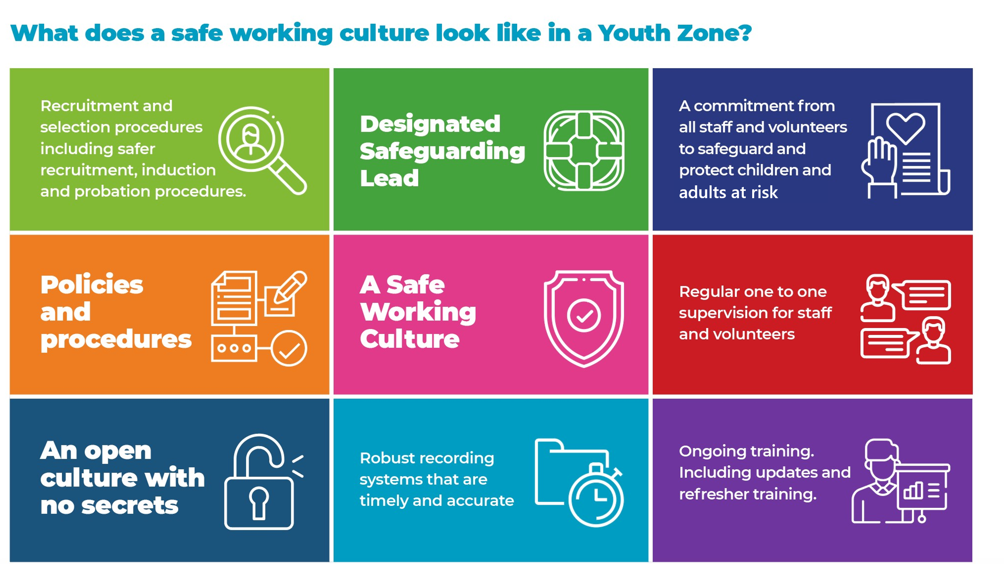

Safeguarding Leads

Every Youth Zone has at least one DSL and one Deputy DSL. While everyone plays a part in safeguarding, safeguarding leads have additional responsibilities:
- Update and review safeguarding policies and procedures
- Ensure all staff and volunteers receive safeguarding training and adhere to policies and procedures.
- Act as the first contact and decision maker for safeguarding concerns
- Appropriately and securely manage, report, store and retain child/adult safeguarding records and liaise with/refer to statutory agencies when required
- Develop collaborative relationships internally (with colleagues and young people), across the Network and with local multi agency partners.
- Establish consistent high standards of safeguarding practice within the Youth Zone.

Legislation & Guidance Framework
There are significant differences in the laws and policies that shape how we safeguard children and how we safeguard adults at risk:’
- The legal framework to protect children is contained in Working Together to Safeguard Children’ (2023)
- The legal framework to protect adults is the Care Act (2014).

Reporting Incidents to External Agencies
Trustees must be assured that appropriate reporting protocols are followed when thresholds of harm are met:
- Report safeguarding concerns to statutory agencies (eg Children’s services & Police)
- Notify funders and commissioners
- Inform relevant criminal record agencies if necessary
- Report serious safeguarding incidents to the Charity Commission

Some considerations as Trustees:
- Are you familiar with and confident in the effectiveness of the Youth Zone’s safeguarding policy, procedure and practice?
- Do you talk to young people, staff and volunteers when you are at the Youth Zone to check if they feel safe, respected and empowered?
- Are you confident that the Youth Zone has a safe and transparent culture at its heart and that you are prepared to be professionally curious and to provide both support and challenge when needed?
- Are you assured that if a serious incident occurred at the Youth Zone, you would be able to evidence high standards of governance around safeguarding?

