



ROLE PROFILE
DIRECTOR OF FINANCE & SYSTEMS


ROLE PROFILE

POST:
DIRECTOR OF FINANCE & SYSTEMS

SALARY:
£80,000-85,000

CONTRACT:
Permanent: Full-time (37.5 hours/week)

LOCATION:
Hybrid working: two days a week in the Bolton or London offices (based in White City) combined with home-working and travel across our Youth Zone network as required.
REPORTING TO:
Chief Executive
BENEFITS:
Agile working with flexibility in working hours; 25 days annual leave plus bank holidays (rising to a maximum of 30 days); birthday leave, additional annual leave purchase scheme; company matched pension; company sick, enhanced parental & adoption pay; Employee Assistance Programme, active and engaged networks to join (including Equity, Diversity & Inclusion) and access to Charity Worker discounts.

OUR COMMITMENT TO EQUITY, DIVERSITY & INCLUSION
As an equal opportunities employer, we welcome applications from under-represented groups; in particular from Black, Asian, Mixed Race & other ethnically diverse individuals, people with disabilities, and members of LGBTQ+ communities. Our dedicated ED&I Group, with support from the Senior Leadership Team, is actively promoting and advancing diversity and inclusion at OnSide, ensuring a culture where everyone can be themselves and thrive.

ABOUT ONSIDE
Potential is everywhere. In every home on every street, from affluent suburbs to inner-city estates. The difference is that some young people get every opportunity to explore their potential. Others don’t.

We’re OnSide, a national charity that believes all young people should have the opportunity to discover their passion and their purpose. To find out what they’ve got and where it could take them.

We fund and build state-of-the-art, multimillion- pound Youth Zones in the country’s most economically disadvantaged areas. We train the amazing people that run them. We offer continuing support via the nationwide OnSide Network, where they can learn and grow, share their stories and celebrate their success together.

These are brand new, purpose-built spaces fizzing with energy, and crammed with incredible facilities. They are staffed by skilled and dedicated youth workers who truly believe in young people – helping them see what they could achieve, and giving them the skills, confidence and ambition to go for it. This is life-changing support that helps tens of thousands of young people from a diverse range of backgrounds to thrive.

It’s inspiring. It’s empowering. And it works.

We know it works because we’ve been doing it for over a decade and we’re in this for the long term. Every new Youth Zone is built on the know-how of the last. Every success story writes the first chapter of the next. And we’re just getting started.

This is passionate, properly funded youth provision, with no ifs or buts. A unique partnership between young people and their community, local authorities and private business leadership, and a growing movement of supporters who believe that how we treat the next generation defines who we are as a society.

Because when we really invest in young people, we all benefit – from who they are now, everything they might become and achieve, and everyone they might touch and inspire. All they need is the chance to shine – an environment where they can be their best selves – and you just watch them go.

It’s about opportunity.

THE ROLE
This role is a key member of the OnSide’s Strategy Team, responsible for shaping OnSide and the OnSide Network’s long-term strategy and financial sustainability.

As a key member of the Executive Team, you will partner closely with the CEO and Board to develop and deliver a financially resilient and scalable organisation, supporting both OnSide and its growing national network of independent Youth Zone

charities.

You will lead the organisation’s finance, systems and data capability—ensuring strong financial
stewardship, high-quality insight for decision-making, and efficient, innovative ways of working.

This is a rare opportunity to shape the financial and operational model of one of the UK’s most ambitious youth charities, with influence extending across a growing national network.

JOB DESCRIPTION
KEY RESPONSIBILITIES
Financial Strategy & Sustainability
- Lead long-term financial planning, ensuring a sustainable model that supports OnSide’s strategy and growth ambitions
- Report to and advise the CEO, the Strategy Team and the Board of Trustees on long-term financial forecasting and business planning
Financial Leadership & Governance
- Ensure robust financial management, compliance and control across the organisation, including optimising the charity’s working capital and cash flow position
- Oversee budgeting, forecasting, reporting, and statutory accounts, identifying risks and recommending corrective actions
- Maintain strong relationships with auditors, banks and key financial partners
- Provide leadership on grant agreements and contract management from a client position as well as contract management and leases from a procurement position
- Ensure full compliance with charity, company law and HMRC requirements
- Ensure necessary insurances are in place for both OnSide and new Youth Zone projects
- Maintain and advise on OnSide’s risk matrix framework
Systems, Data & Insight
Work in partnership with, and provide support to, the Head of Systems & Impact to:
- Drive the development of systems and data capability across OnSide and the Network
- Ensure high-quality management information supports strategic decision-making
- Champion automation, efficiency and continuous improvement
- Oversee impact measurement
Network Support & Influence
- Monitor and advise on overall financial and compliance risks across the OnSide Network through providing strategic financial advice and support to CEOs and Boards
- Oversee the delivery of a management accountancy service to those Youth Zones that opt in to this service (business partner approach)
- Lead financial input into new Youth Zone developments, including setting up bank accounts, systems and processes, maintaining appropriate cash flow, and adhering to the terms and conditions of external funders
- Act as OnSide’s nominated Trustee on a Youth Zone Board
General
- Provide leadership, direction and management of the Finance and Systems Teams including direct management of the Head of Systems & Impact who line manages all other team members
- Promote equity, diversity, fairness and inclusion in all aspects of talent development.
- Model behaviours of the OnSide culture; consistently defining ways to identify and reinforce behaviours that align with OnSide values

PERSON SPECIFICATION
Applicants will be expected to demonstrate the experience, skills, knowledge and aptitudes listed below throughout the recruitment process. However, if you don’t meet every single requirement but feel you have strong and relevant transferrable skills or lived experience to draw from, we encourage you to apply anyway.

Why? Studies have shown that women, non-binary people and Black, Asian, Mixed Race & other ethnically diverse people are less likely to apply for jobs unless they meet every single criteria/competency. OnSide are dedicated to driving change and to building diverse, inclusive, and authentic workplaces, so if you’re excited about this role but your past experience doesn’t align perfectly, please tell us how your experience is transferrable. You may be just the right candidate!

SELECTION CRITERIA
EXPERIENCE
Proven experience at a senior level in a finance role with responsibility across the whole finance function (ideally also including responsibility for the systems function)
Substantial financial leadership across scaling organisation or multi-entity structure spanning organisational planning, analysis and improvement, ideally a national-level charity
Track record of highly effective collaborative working with senior colleagues at Executive and Board Level
SKILLS, KNOWLEDGE AND APTITUDES
Strong leadership skills and the ability to develop team members to their full potential
Strong ability to build effective relationships and influence at senior levels
Committed to devising solutions to problems, not seeing obstacles
Ability to manage multiple priorities effectively and work well under pressure to achieve deadlines
Excellent communication skills with effective report writing and presentation skills
A self-starter, flexible, creative and able to show initiative
Understanding of the charity context
A believer: a genuine passion and commitment to OnSide’s mission and goals
QUALIFICATIONS
Fully qualified accountant (CCAB recognised)

GENERAL INFORMATION

This role will be contractually based at our Bolton or London (White City) office with hybrid working; in practice this will involve working two days a week in the office, combined with home working and travel across our Youth Zone network as required. It will also require occasional overnight stays. Homeworking risk assessments are carried out for all employees working from home.

OnSide will contribute towards reasonable travel costs for candidates invited to attend face-to-face interviews when they are travelling from outside the local area. This approach reflects OnSide’s commitment to fairness and equality of opportunity.

In accordance with our Child Protection and Safeguarding procedures, this position requires a Basic DBS check.

APPLICATION PROCESS


To apply, please submit a CV and a one-page cover letter via the OnSide website at Work with OnSide - OnSide Youth Zones. While we encourage the responsible use of AI to support your application, your cover letter should be personally written and clearly set out how you meet the person specification.

In addition, please provide the following information:

- Confirmation you are eligible to work in the UK (documentary evidence will be required before a job offer is confirmed)
- Any reasonable adjustments we can make to assist you in your application or the selection process
- How you demonstrate your commitment to equity, diversity & inclusion.

CLOSING DATE FOR APPLICATIONS:

12noon on Wednesday 8 July
(We may close this role early if we receive a high volume of applications, so we encourage you to apply as soon as possible.)

INTERVIEWS:
First stage interviews (virtual):

Wednesday 15 July 2026

Second stage interviews (in-person):

w/c 27 July 2026

There will also be a short, values-based phone interview between Stage 1 and 2.

For information on how OnSide processes your data, go to
OnSide Youth Zones Job Applicant Privacy Notice - OnSide Youth Zones



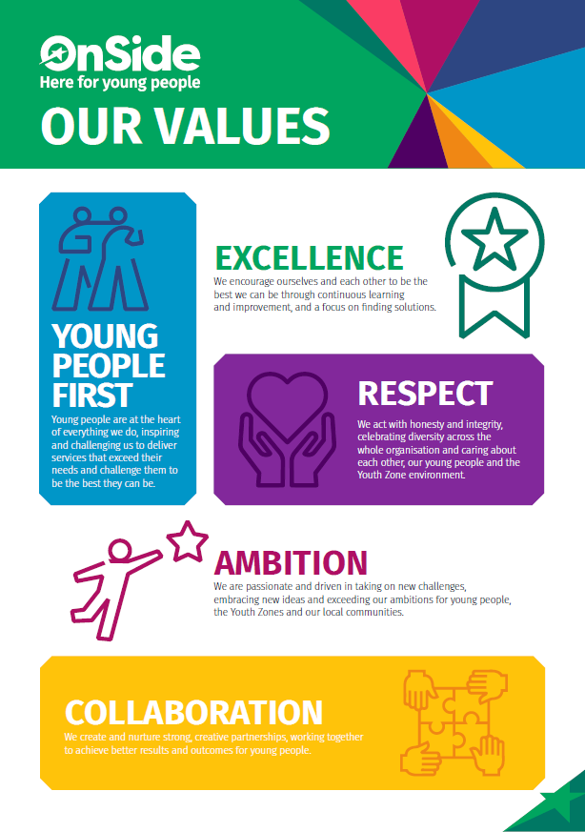

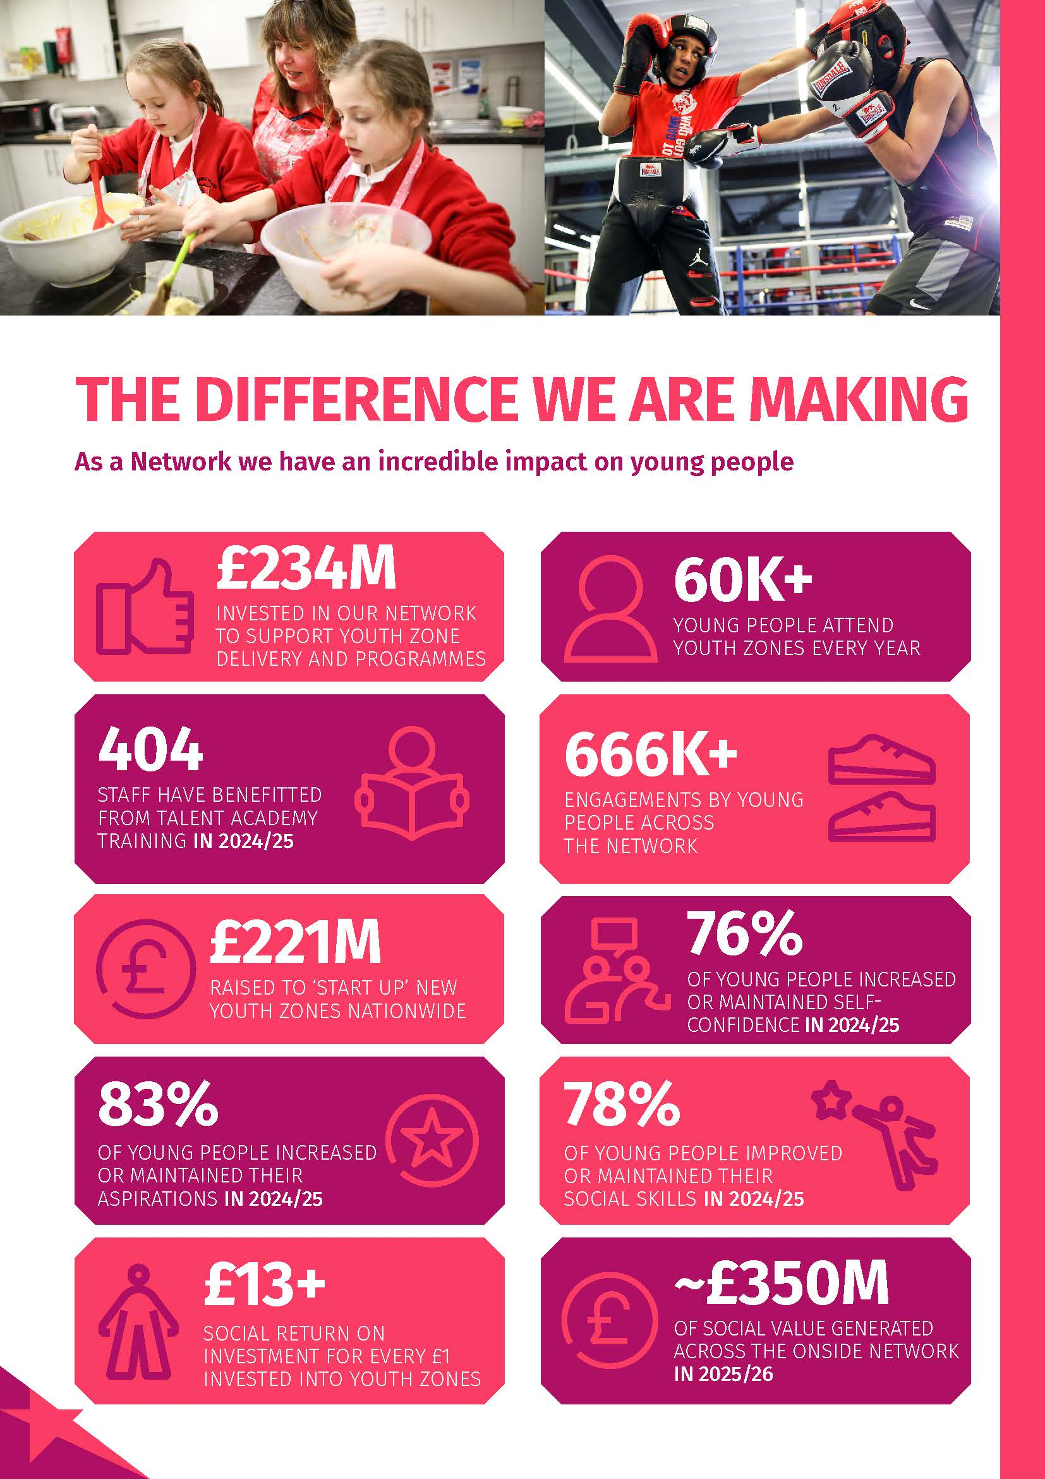
6

