



CANDIDATE INFORMATION PACK
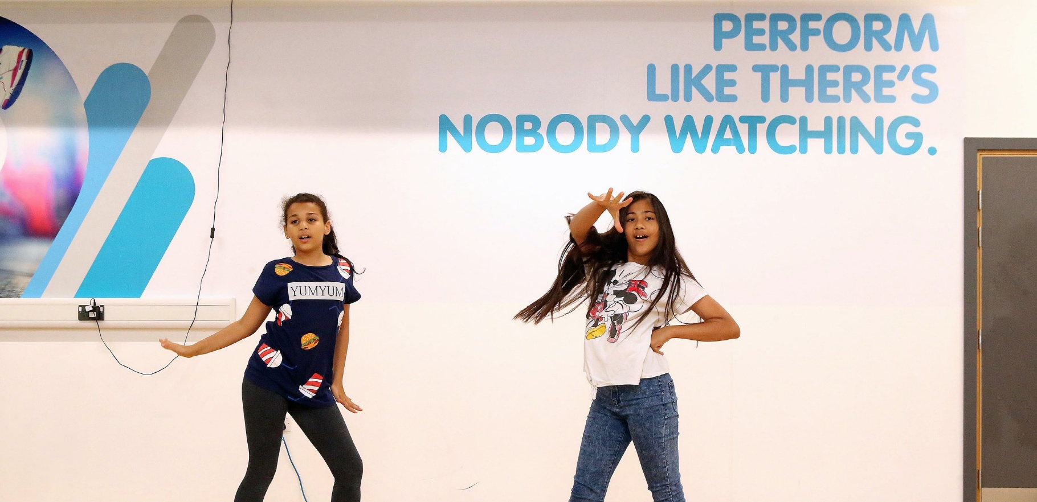
CHAIR OF TRUSTEES
OnSide Youth Zone Thames Gateway

Welcome from Jamie Masraff, Interim Chair

Thank you for your interest in becoming Chair of OnSide Youth Zone Thames Gateway. Opportunities like this do not come along very often.

Over the last few years, I have had the privilege of working alongside an extraordinary group of trustees, staff, partners, and supporters to turn an ambitious vision into reality: establishing a world-class youth centre that will benefit the lives, aspirations and futures of thousands of local young people.

We are now approaching a pivotal moment. The foundations have been laid, momentum is building and in just over a year the new Youth Zone will open its doors. The Chair who joins us now will have the unique opportunity not simply to lead an established organisation, but to help shape, launch and embed a new institution that can serve young people for generations to come. You will also benefit from the Youth Zone being part of the wider national OnSide Network - a thriving group of independent local charities, each committed to exceptional, life-changing youth work that has a genuine long-term impact on the lives of local young people.

The impact of a Youth Zone is difficult to appreciate fully until you see it for yourself. Young people finding confidence they never knew they had. New friendships formed. Talents discovered. Lives changed. Every successful Youth Zone is built on the belief that every young person deserves somewhere to go, something to do and someone to talk to, and that belief sits at the heart of everything we are creating here.

The role of Chair carries significant responsibility, but it is also incredibly rewarding. You will lead a committed Board of Trustees, work closely with an exceptional Chief Executive and senior leadership team, and help ensure that the organisation is both ambitious and well governed. You will be an ambassador for the Youth Zone across the wider community and play a key role in building the relationships, partnerships and support that will enable the charity to thrive long into the future.

We are looking for applicants with substantial experience of organisational leadership and governance, someone who understands how to balance support and challenge, who can think strategically, inspire confidence and create consensus around a shared vision. We are particularly interested in candidates who are passionate about young people and who can use their influence, networks and relationships to help strengthen the Youth Zone's profile, sustainability and fundraising ambitions. Most importantly, we are looking for someone who believes that every young person deserves the opportunity to thrive.

I hope you will consider joining us on this remarkable journey.

Best wishes,


Jamie Masraff
Interim Chair, OnSide Youth Zone Thames Gateway






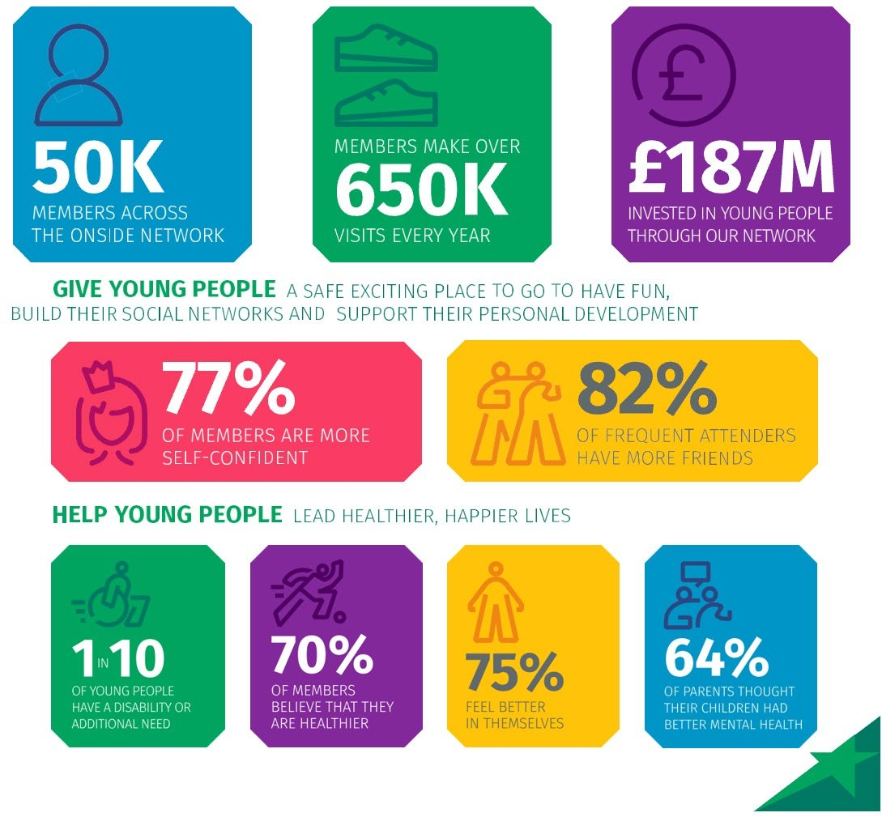

ROLE PROFILE
POST:
Chair of the Board of Trustees

ONSIDE YOUTH ZONE THAMES GATEWAY:
Thurrock’s Youth Zone, named OnSide Youth Zone Thames Gateway, is set to open in winter 2027.
At Thames Gateway, we believe that all young people in Thurrock should have the opportunity to discover their passion and their purpose, to find out what they’ve got and where it could take them. Our Youth Zone will be a purpose-built space fizzing with energy and crammed with incredible facilities. It will be staffed by skilled and dedicated youth workers who truly believe in young people – helping them see what they could achieve, and giving them the skills, confidence and ambition to achieve their potential.

When open, we will deliver life-changing provision to help over 3,000 young people aged 8-18 (and up to 25 for young people with additional needs) annually.

We will be open at least six days a week while schools are closed - that’s evenings and weekends, plus all through the school holidays. We will offer a safe and active space for young people to flourish in their leisure time, where their interests can be nurtured, and they can grow as individuals. Averaging 1,000 visits per week, this will be a charity that the whole community can be proud of, and you can be part of that journey.

Entry will be just 50p with an annual membership of just £5, giving a young person access to over 20 activities per night. In addition to our open-access provision, we will run targeted projects that bring specific outcomes to some of those most in need of additional support and interventions.

Youth Zones are a proven model of youth service provision that is aligned to community needs and supported by cross-sector funding. We will offer affordable access to a broad range of sport, arts and employability services, designed to empower young people to lead healthier, positive and more active lives – raising their aspirations for themselves and their community.

The facilities will be second to none, delivering sporting, artistic, cultural and general recreational activities each session. The outstanding quality of the facilities is a concrete demonstration of the belief that young people deserve the best.

ABOUT ONSIDE:
Potential is everywhere. The difference is that some young people get every opportunity to explore their potential. Others don’t. It’s about opportunity.

Thames Gateway is proudly part of the OnSide Network, a federated network of likeminded independent charities that support each other and are aligned in their belief that all young people should have the opportunity to discover their passion and their purpose. To find out what they’ve got and where it could take them.

OnSide is part of this network and has a distinct role in funding and building state-of-the-art, multimillion- pound Youth Zones in the country’s most economically disadvantaged areas. OnSide also trains the amazing people that run them. And it offers continuing support via the nationwide OnSide Network of 19 Youth Zones (and growing), where colleagues can learn and grow, share their stories, and celebrate their success together.

This is passionate, properly funded youth provision, with no ifs or buts. A unique partnership between young people and their community, local authorities and private business leadership, and a growing movement of supporters who believe that how we treat the next generation defines who we are as a society.

Because when we really invest in young people, we all benefit – from who they are now, everything they might become and achieve, and everyone they might inspire. All they need is the chance to shine – an environment where they can be their best selves – and you just watch them go.

THE ROLE:
The Chair will be pivotal in shaping our new charity’s governance, mission and long-term sustainability. With a key role to play with increasing our network and spearheading our fundraising campaign, the Chair will hold the Board and Senior Leadership Team to account, providing inclusive strategic leadership to the Board of Trustees, ensuring that each trustee fulfils their duties and responsibilities for the effective governance of OnSide Youth Zone Thames Gateway.

DUTIES AND RESPONSIBILITIES:
Strategic leadership:
- Provide leadership to Thames Gateway and its Board, ensuring that Thames Gateway has maximum impact for its young people once open
- Actively support fundraising for Thames Gateway and encourage the rest of the Board to do so as well
- Support the shaping of Thames Gateway’s values and ensure these are at the forefront of strategic decisions
- Act as an ambassador for Thames Gateway and its mission
- Represent Thames Gateway within the OnSide Network together with the CEO

Governance:
- Chair the Trustee Board effectively and efficiently, bringing impartiality and objectivity to the decision-making process
- Sit on other sub-committees of the Board as determined by the Terms of Reference of those committees
- Work closely with the CEO to give direction to policy-making and to ensure that meetings are well planned and reflect the responsibilities of trustees
- Monitor that decisions taken at meetings are implemented.
- Work with the CEO to ensure that the Board fulfils its duties to ensure sound financial health of Thames Gateway, with systems in place to ensure financial accountability
- Ensure that the Board regularly reviews major risks and associated opportunities, and satisfies itself that systems are in place to manage and mitigate risks
- Ensure that Thames Gateway is compliant with all aspects of its status as a UK charity and company, and operates within its charitable objectives
- Work within any agreed policies adopted by Thames Gateway

Board Efficiency and Effectiveness:
- Ensure that Trustees are fully engaged, fulfil their duties and that decisions are taken in the best, long-term interests of Thames Gateway and that the Board takes collective ownership
- Foster, maintain and ensure that constructive relationships exist with and between the Trustees
- Support the recruitment of the Deputy Chair and other vacant Trustee positions
- Appraise the performance of the Trustees on an annual basis and remove any Trustee who is unable to meet the expectations
- Ensure the Board is regularly refreshed and incorporates the right balance of skills, knowledge and experience

Relationship with the CEO and the Senior Leadership Team:
- Establish and build a strong, effective and constructive working relationship with the CEO, ensuring they are held to account for achieving agreed strategic objectives
- Support the CEO through regular contact, developing and maintaining an open and supportive relationship within which each can speak openly about concerns, worries and challenges whilst respecting the boundaries which exist between the two roles
- Liaise with the CEO to maintain an overview of Thames Gateway’s affairs, providing support as necessary
- Conduct an annual appraisal and remuneration review for the CEO in consultation with other Trustees
- Ensure that the CEO has the opportunity for professional development and has appropriate external professional support

GENERAL INFORMATION
This role is a Trusteeship and as such is unremunerated. However, reasonable expenses may be covered by Thames Gateway, as per our expenses policy.

As one of the leaders of the charity in terms of fundraising, it would be welcomed that the Chair will be (or become) a donor to the charity. The level of this donation is of course commensurate with the Chair’s means and there will be no pressure to donate more than is affordable.

Thames Gateway currently has a Trustee Board of five people and is in active recruitment to fill the remaining vacancies ahead of opening in Winter 2027. All Trustees serve a three-year term that is renewable but would be unlikely to exceed maximum of 9 consecutive years without rigorous review by other Trustees.. All new Trustees will have a portfolio.

The current portfolios are: Chair; Deputy Chair; Youth Zone Delivery Quality; Network Champion; Legal; Governance; Facilities & Health and Safety; Local Engagement; Safeguarding; OnSide Nominated Trustee; Treasurer; Fundraising; Marketing & Communications; and HR.

Thames Gateway’s projected budget for 26/27 is approximately £500,000, with this increasing to £1.45m in 27/28 when the Youth Zone opens and is fully operational.

For further details about Thames Gateway’s finances, operations, strategy etc, please contact Bethanie Cundy (Chief Executive), who will be happy to give an informal briefing to any prospective candidate.

Please also complete our Equal Opportunities form, available here, which will enable us to continue our v
APPLICATION PROCESS
The appointment will ultimately be made by the Trustee Board as a whole, however the Trustees have agreed the following process:

In the first instance, please send a CV and cover letter (no more than one side of A4) to Bethanie.c@onsideyzthamesgateway.org.

Bethanie Cundy (Chief Executive) and Jamie Masraff (Trustee) will organise short online interviews. We will then shortlist.

Final-round interviews will be in-person at Future Youth Zone, Barking & Dagenham with a panel of Trustees.

In accordance with our Child Protection and Safeguarding procedures, this position requires an enhanced DBS check.

The strength of the OnSide community comes from the diversity of the people within our vibrant network. We are proud that our Youth Zone team reflects the communities we serve, and we value people working together from a range of different backgrounds and with different experiences, all with a shared passion for boosting the aspirations of young people in Thurrock. Diversity brings innovation, fresh ideas, and creativity, and we actively strive to create a culture that is truly inclusive and fair for all and where everyone in the team can be themselves and thrive.

CASE STUDY: HANNAH AND FAWZIYA’S STORY
We firmly believe that Youth Zones are places that change lives, but don't take our word for it - our young people tell us this all the time!

Two examples are best friends Hannah (17) and Fawziya (16). Hannah and Fawziya didn't know each other before they came to Unitas Youth Zone in Barnet. They both attended a session in the Music Room and it is this session that they credit with being the start of their friendship.

Both avid film and media enthusiasts, they told us that "the Media Room has changed our lives" and when asked about how Unitas Youth Zone has impacted their lives outside of the Youth Zone, Fawziya said, "I found my passion for film at Unitas. I wouldn't have applied for the BRIT School and be studying film and media there if I hadn't been coming here."

Similarly, Hannah told us that Unitas showed her that she could make a career out of something that previously had just been an interest. The facilities the Youth Zone offers are vital to both girls. "The big impact is that there are creative spaces here … I think it's really important to have these creative spaces where we can nurture the talents that we have ... I think you don't really realise that until you enter a place like this where you can really open your eyes."

Hannah now attends the London Screen Academy in Islington, and Fawziya attends the BRIT School in Croydon. Fawziya continues to come to Unitas after college because "I didn't have anything to do before coming here ... it's engaging here and the engagement is what pulls people in, and it's what makes you want to do things."

They continue to create new projects such as 'CHATBOX', a series of video blogs where they discussed issues that affected them and their peers and Fawziya was even selected as one of the winners of last year's Show and Tell photography competition. Selected from over 22,000 submissions, her submission was featured on over a hundred billboards around the UK! Meanwhile, Hannah has put her film skills into practice in Unitas' Media Squad, doing all the videography for our recent amateur boxing events.

When asked about how Unitas' youth workers support them, Fawziya said "to have someone who believes in you is one thing but to have someone to tell you that you are capable of more than you think and are yet to discover is really important." Hannah echoed these sentiments "The youth workers really push us to become what we can truly be and reach our full potential."


We asked them to sum up Unitas. "It’s like a second home. It doesn't feel like you come here into another school environment, it feels like I'm going home, just with more people! ... it's an environment with a different meaning and a different purpose. Even though it's got this incredibly homely vibe, it's still somewhere we are pushed to be our best, and to do whatever we think is possible.

